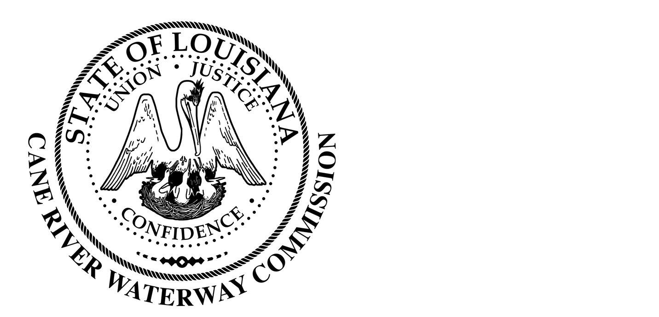
Cane River Waterway Commission
Minutes
February 15, 2023

There was a public hearing of the Cane River Waterway Commission on February 15, 2023, at 6:00 pm located at 244 Cedar Bend, Natchez, Louisiana.
The hearing was called to order and roll was called with the following members being present: Mr. Rhodes, Mr. Methvin, Mrs. Banks, Mr. Methvin and Mr. Wiggins. Absent: Mr. Paige
Also present was Director of Operations Jason Adcock and Attorney Tommy Murchison.
Ms. Hallie Errington with the Natchitoches Regional Medical Center Foundation was present to thank the Commission for always supporting the TapTober fest. Ms. Errington stated that the Foundation wanted to do more throughout the year to recognize the Commission for their sponsorship. She stated the Foundation would like to get the Commission to commit to sponsoring TapTober earlier in the year to give recognition to the Commission throughout the year. Upon motion by Mr. Methvin, seconded by Mr. Wiggins and unanimous vote by Mr. Rhodes, Mr. Methvin, Mr. Wiggins and Mrs. Banks with Mr. Paige absent the Commission approved the sponsorship of TapTober in the amount of $30,000.
Mr. Rodney Harrington with the Natchitoches Jazz Festival was present to thank the Commission for its yearly sponsorship of the Jazz Fest. Mr. Harrington request that the Commission be the lead sponsor of this years Jazz Fest. Upon motion by Mr. Methvin seconded by Mrs. Banks and unanimous vote by Mrs. Banks, Mr. Rhodes, Mr. Methvin and Mr. Wiggins with Mr. Paige absent, the Commission approved the sponsorship of Jazz Fest in the amount of $25,000.
The minutes of the regular meeting on January 18, 2023, were presented. The Chairman opened the floor to public comments and after discussion the Chairman closed the floor to discussion. Upon motion by Mr. Wiggins seconded by Mrs. Banks and unanimous vote by Mrs. Banks, Mr. Rhodes, Mr. Methvin and Mr. Wiggins the Commission approved the minutes of the January 18, 2023, meeting as written.
Mr. Sonny and Rebecca Lavespere were present to address their concerns of the bass boats speed and the water level. Mr. Methvin advised the Lavespere’s that the Commission had regulations on when to close the river when the water level rises above 99.5 msl. Mr. Adcock explained to Mr. Lavespere that the river is measured from the top of the water and how far it is above mean sea level. At the time of the meeting the river level was at 98.3 msl. Mr. Adcock also stated that most older seawalls were only built 1 foot above pool stage when it is recommended to at least be 2 foot above to help prevent boat wakes from over lapping.
Upon motion by Mr. Methvin seconded by Mr. Wiggins and unanimous vote by Mrs. Banks, Mr. Rhodes, Mr. Methvin and Mr. Wiggins to go in to Executive Session.
At 7:15 pm the Commission returned from Executive session. Upon motion by Mr. Methvin seconded by Mr. Wiggins and unanimous vote by Mr. Rhodes, Mrs. Banks, Mr. Wiggins and Mr. Methvin with Mr. Paige absent, the Commission approved the pay raise of Director Jason Adcock of $5,000 annually with an $800 monthly stipend for insurance since no group plan is available to Mr. Adcock, along with a vehicle allowance of $950 monthly until the purchase of a work vehicle.
There being no further business to come before the Board, upon motion by Mrs. Banks seconded by Mr. Wiggins and unanimous vote by Mr. Wiggins, Mrs. Banks, Mr. Methvin and Mr. Rhodes, the meeting was adjourned.

________________________________
Approved by
__________________
Date

